CEP Lab 6
By: Anthony Garcia

Training Phase
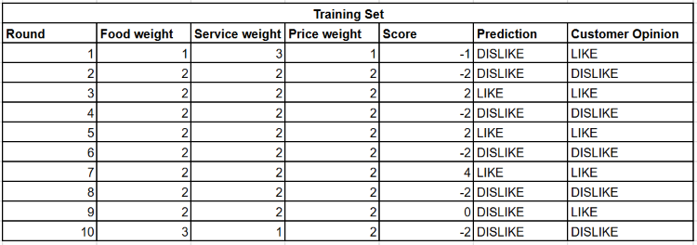
The model initially placed too much importance on service. After the first mistake, the weights became more balanced. After the ninth round, food became the most important feature.

Testing Phase
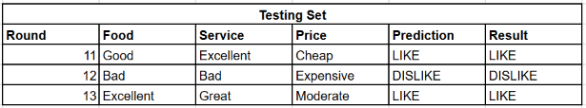

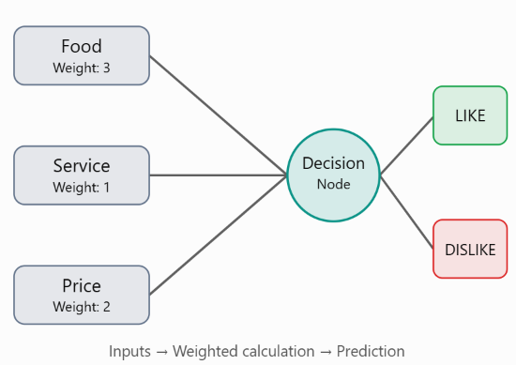

We froze the learned weights at:
- Food = 3
- Service = 1
- Price = 2
We then applied them to three new scenarios without making any further adjustments.Testing accuracy shows that we were able to correctly predict three customer opinions.
Team comparison: The final weights indicate that food was considered the most influential feature, followed by price, and then service.

Reflection
The model improved by adjusting its weights whenever it made an incorrect prediction. Initially, it placed too much importance on service then it gradually increased the importance of food and reduced the importance of service.
Weights represent the relative influence that individual inputs have on a decision. A larger weight means that an input has a greater impact while a lesser weight means lesser impact on the final decision.
Our simulation demonstrates a simplified version of how a neural network works. Inputs are assigned numerical values, multiplied by weights, and combined to produce an output. During training, weights are adjusted based on prediction errors while real neural networks use more sophisticated techniques.
Additional inputs could allow the model to consider more factors when making predictions while additional layers could allow the network to learn more complex relationships between inputs.
Neural networks are used in image recognition, speech recognition, recommendation systems, language processing, and fraud detection. They learn patterns from training data and use those patterns to make predictions about new information.

